IT Project Management System

Process Report

Group 4

Group Members: Henrik Koster (305916), Kim Tranberg (172394), Aleksandrs Bistrovs (304542)

Supervisors: Astrid Hanghøj, Steffen Vissing Andersen

VIA University college

Character Count:

Software engineering

Semester 1

Date: 17/11/2020

# 

**1. Introduction** **2**

**2. Group description** **3**

**3. Project initiation** **5**

**4. Project description** **6**

**5. Project execution** **7**

**6. Personal reflections** **8**

Aleksandrs 8

Henrik 11

Kim 12

**7. Supervision** **13**

**8. Conclusions** **14**

**9. Sources of information** **15**

# 

# 1. Introduction

The project is composed of four primary stages: Project Description, Analysis, Design and Implementation.

This stage provides the foundation for the rest of the project since it entails the description of the problem and how we will go about solving it. We tried to make this as clear and concise as possible while still describing all the critical aspects of the project in the form of a background description, definition of purpose, problem statement and methodology. Due to the late formation of our group, we only had a few days to complete the project description. However, we were able to use our work from our previous groups and formulate that in our own words. For this reason, we were able to complete the project description in no more than two days.

Of all the project’s stages, the analysis was the most time consuming, taking a total of 22 days to complete, making up roughly 22% of the entire project duration. This is largely in part due to the substantial amount of planning required in the form of: functional and non-functional requirements, a use case diagram, use case descriptions, activity diagrams and a domain model. Over this period, we had several meetings to discuss who was working on which aspects of the analysis. The most important meeting being after our first hand-in as we received a considerable amount of constructive feedback from both our supervisor and partner group. Our last meetings involved compiling all our work into one clear document ready for hand-in.

The design stage was the shortest stage, taking only 11 days to complete and making up roughly 11% of the entire project duration. Nevertheless, it was critical that we did this as accurately as possible since a solid design will always make implementation easier and vice versa. Design involved the formation of classes and sequence diagrams. Over this period, we had several meetings in which we worked collaboratively. Unlike the previous stages where we could work on separate aspects in our own time, it was critical that we formulated the classes and sequence diagrams together as these are all interlinked in some way and the slightest mistake could cause problems down the line. This helped us to avoid confusion and ensure all our work was consistent and met a high standard.

The Implementation stage took 17 days to complete, making up roughly 17% of the entire project duration. The majority of this stage was done remotely and meetings were carried out on a daily basis. We used Git and Github because it allowed us to work on our program in unison without the hassle of continuously merging our work which would inevitably cause a variety of problems. In hindsight, this was a great decision because it allowed for a more professional workflow. Had we done this without Git, we would probably spend as much time fixing errors as we did coding.

The project as a whole had a total duration of 3 months and 5 days and throughout this time, our dedication to consistent work as well as our commitment to meeting regularly helped us produce a functional program with very few complications and disagreements along the way.

# 2. Group description

Our current group consists of three members: Aleksandrs, Henrik and Kim.

Aleksandrs is 28 years old, who comes from Latvia. Previously has been studying International Hospitality management in Odense, where he gained some experience in project writing. However, since it is a very different field, the previously gained experience did not prepare him for the requirements here.

I am Henrik and I am 19 years old. I was born in Portugal in January 2001. I have Swedish and Portugese nationality. I studied a general engineering course in Loughborough College, United Kingdom. In my last year, me and 3 other classmates designed a bike trailer from scratch. As such, we were required to document the whole process from start to finish, including research. For this reason, I already have experience writing project and process reports.

Kim is 30 years old, of Danish nationality. Has previously been studying in two different higher educations, but did not complete any of them. He has experience with problem based learning, and project work in general, since highschool.

In the very beginning the team consisted of four members, namely - Aleksandrs, Kim, Henrik and Laurentiu. Later on, that number has been reduced to three, since one of the students decided to stop the programme due to personal reasons. The current group - Aleksandrs, Kim and Henrik come from different cultures, have different backgrounds and nationalities, which are all contributing factors to the work as a group. Therefore, it is important to take the previously mentioned factors into consideration when reflecting upon the period of the project. To help understand the differences and provide the reader with the background of each student, the aid of different cultural models, and personality profiles are discussed further below.

The cultural theories like Hofstede and Hall’s theory helped our team to realize and take into account our cultural differences. Coming from different places, we have noticed that we have different ways of thinking, preferred ways of working, and it also affects the way we communicate with each other. For example, if we take a look into a Hall’s theory about low and high-context cultures, we can see that low-context cultures are very different from high-context cultures. In our team we have experienced a slight problem, where the members had a conflict due to different ways of communicating. To be more precise, in the very beginning, when we were still four members in the group - one of the members from a high-context culture (Romania) had a hard time accepting the critique, which was given by a member from a low-context culture (Denmark), where “saying what you mean and mean what you say” is a preferred way of communicating, rather than being indirect in high-context cultures. Becoming aware of this, we learned that we may run into such problems in the future, and there is no point in getting angry with each other.

*(Note: this paragraph was written during the SSE classes)*

Looking at the cultural model of Hofstede, to be more specific, to the dimension of Individualism (see figure 1. *Geert Hofstede cultural model - country comparison*), we noticed that some of the group members were more able to work on their own after splitting up the tasks (members with the highest scores in the mentioned category), whereas some of the members still required some sort of guidance in a form of collective thinking - no work could be done without discussing it first with the other members first. (members who score low in the mentioned category). Furthermore, looking to the rest of the dimensions in the model, we can see that some cultures are more similar than others. For example, it is clearly visible that Romainian and Portuguese culture is more alike, whereas Danish and Latvian culture also have more in common than the first two. This could also be felt in the group, members of these countries were better at cooperating with each other.

*(Note: this paragraph was written during the SSE classes - modified and added information)*

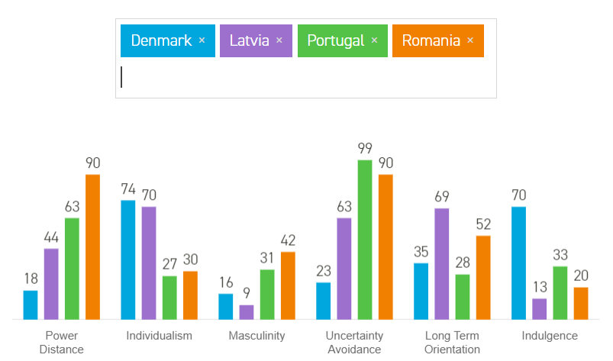

Fig. 1. Geert Hofstede cultural model - country comparison (Hofstede Insights, 2020)

Something important to consider was also our personalities. During the semester, we did personality tests in the lessons of SSE. The profile test divided the respondents into 4 categories with a different colours: red, yellow, green and blue. Each colour represents different characteristics, for example, red is more of a leader, yellow is creative and social, green is more of a friendly type, and blue is detail oriented (E-stimate Personal Profile, 2019). Based on our results from the mentioned test, our personalities match up very well. In general we all have a mix of the same colours, mostly blue, green and a bit of yellow. This means that we can come to an agreement for all of our discussions without them reaching a personal level, and turn into a serious conflict. A downside to our group composition is that our discussions can sometimes take longer than needed, since we are lacking a bit of the red colour, which is more of a leading type and would try to reach an agreement way faster.

*(Note: this paragraph was written during the SSE classes - modified and added information)*

# 3. Project initiation

In the beginning of the semester, the students were given a task to design and implement a single user system, based on the interview with “Colour IT” given by the supervisors. During the SEP (Semester project) lessons, the students were learning step by step how to analyze such an interview, how to make a list of requirements using the SMART model, how make a Use Case diagram using the software called Astah (diagram modelling program) and how to write Use Case descriptions. Later on, we were introduced to the design part of the project, where students learned how to make Activity diagrams, as well as the Domain model using already previously mentioned software - Astah. Combined with the skills from other subjects, the students could slowly begin the process of working in their study groups while still learning the above mentioned topics.

The group has formed rather late during the semester, that is due to the fact that all of the team members have experienced different problems in the previous groups they were members of. For some members it was the difficulty communicating to their former group, for some it was lack of motivation due to the dysfunctionality and lack of participation of their former group in the lessons. That led to solving the problem and seeking out a new group. When finally the current group has formed (around the beginning of November), the project began and slowly gained pace towards the end of the month. The positive outcome of changing the group has allowed us to quickly adapt and begin performing, thus skipping the norming and storming stages described in the group dynamics model by Bruce Tuckman (MindTools, 2020). Because of the similar beginning phase of the group members and the common goal followed by the time pressure, the team could quickly accept each other, establish norms and harmony, and skip the conflicts.

In order to accomplish all the tasks and manage to be on time for the deadline, the team had to plan ahead. In the norming stage of the group, the team has made a contract (*see Appendix A - Group Contract*), where we had to sit down and discuss all the issues we might encounter in the future and how to deal with them, in the contract we also mentioned how invested are we in the topic and how much time we are willing to spend for the project, as well as the general guidelines for showing up on meetings and respecting each others time and deadlines. Here the team also used a tool called Gantt chart, which illustrates the schedule of the project. It is a great tool to divide the project into easily viewable sections, to which the approximate time is assigned, that way helping the user of such a tool to do the project on time or meeting the deadline.

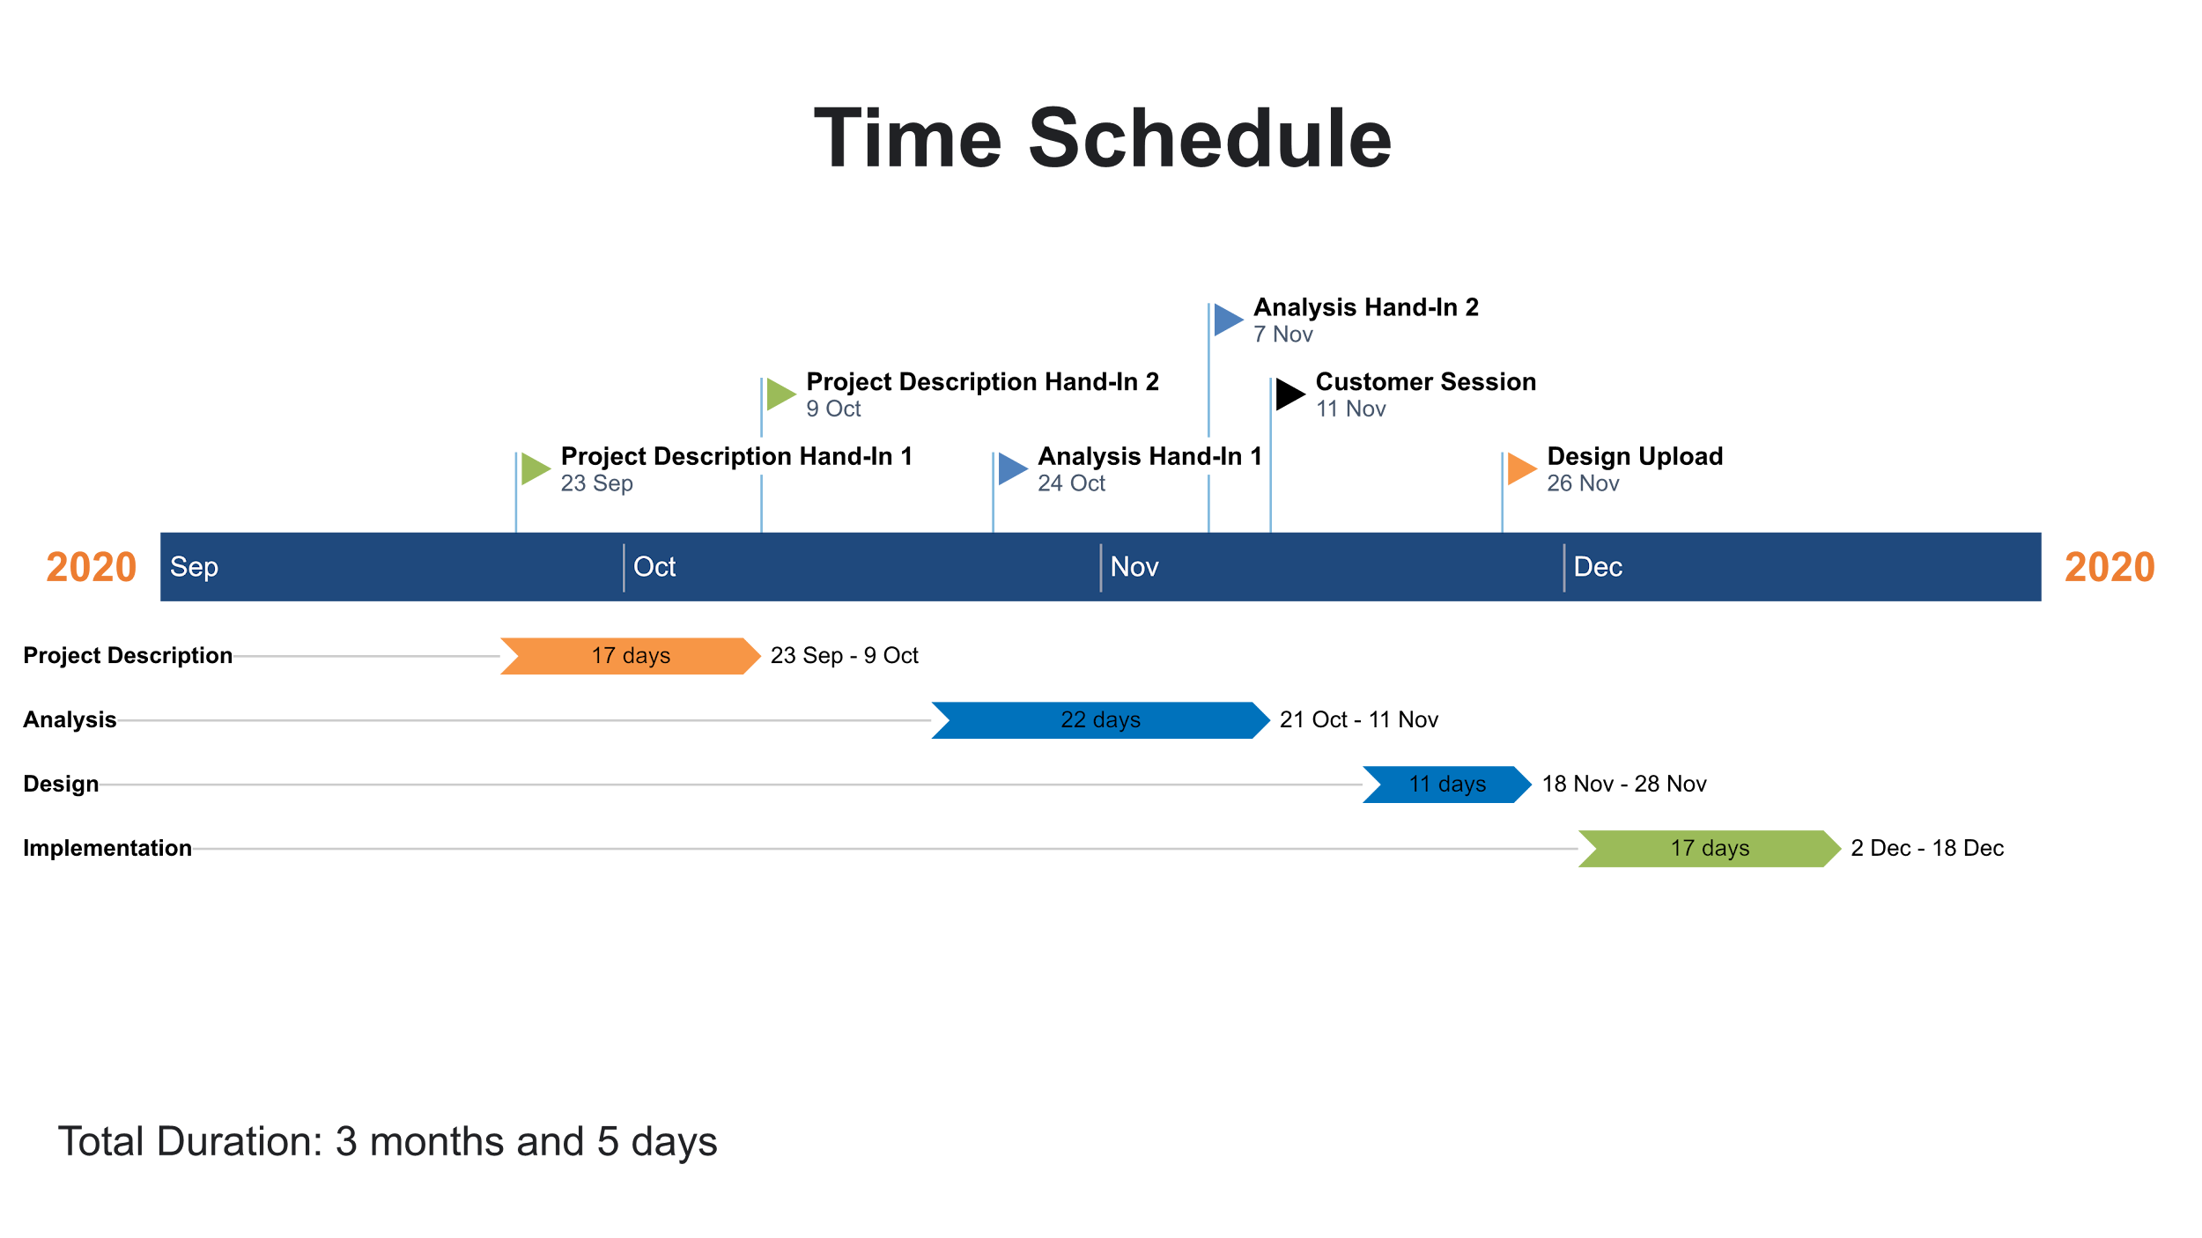

Fig. 2. Gantt chart time schedule.

# 4. Project description

Before starting any project, the team had to make sure that the problem is clearly understood and defined, that is where the project description came in handy. Because the current team formed later in the semester, the project description phase was written twice - once in the previous groups, and the second time in their current group. It cost time and slowed down the process of getting to an actual project writing, but enabled the team to revise and think about the problem more, thus making it more clear.

The problem was defined by sitting down with the team and analyzing the interview, while also thinking in the broader perspective. Here the team needed to understand why would companies have such needs in general and how it would better their efficiency at the workplace. These questions kickstarted the research and enabled the team to become more knowledgeable about the given topic.

The goal which was set during the project description resulted in the ready product followed by the report, where the product was an IT management system and the report describing it. It was a challenge to make it a reality due to several reasons: one of them being the lack of knowledge and expertise in the field, since we are the first semester students. We spent way too much time on things, which would not take as long given more experience. Second, the lack of time - uncertainty followed by the time pressure resulted in quick and heedless decisions, which in turn made it hard to achieve the intended results. One of the features that the system should have included was the website. Unfortunately, by spending too much time on all the other aspects of the project, the team did not have time to implement this feature.

# 5. Project execution

The main plan for our project was mostly pre determined by the different deadlines set by our supervisors. We did not follow a time schedule or really utilize the one that was made.

We mainly used a waterfall approach, which was really great for a first semester project, since we had to learn all the different stages of developing a system, in chronological order. If we had to use an iterative approach, we would first have to know all the stages of system development. Since in an iterative approach you look at one requirement at a time and do all the steps for that one requirement, e.g. analysis, design, implementation and testing. However, at the same time the waterfall approach was not that great for us, since we did not have much previous experience with system development. In the end, this meant that when implementation was done, we had to go back and redo previous steps, like analysis and design. This was also a reason for our poor time utilization in the two project weeks. But for next semester an iterative approach will be much more relevant, since we now have more experience with the process of developing a system.

We did not really have a thorough plan for our project, so we could not follow up on it.

The main goal of the project was to design and develop an IT project management system, which was successfully achieved. However, given the time limitation, the team was not able to “polish” the system, to be more precise, to make it perfect by achieving the full potential with all the functionality included. In addition, the team did not manage to make a website for the system. Despite it, we are still satisfied with the results we got, as in the beginning of this semester nobody thought it was possible.

The main risks we foresaw were not meeting deadlines, unequal workload and crunch time. Fortunately, we were able to complete all our work on time. This was due in part to our regular meetings to ensure all the work was completed before handin dates. However, we didn't have any measures in place for unequal workload, this led to some people doing more than others in particular stages, although this was most prominent during implementation. Lastly, the only crunch time we experienced was towards the very end when we were working on project and process reports. This could have been avoided if we simply started documentation earlier. Better yet, we could have worked on the project and the report simultaneously, which would have allowed for more time to polish the final product itself.

Organization was poor from the very start of the project. We did not assign roles to tasks and as such, we were not able to coordinate who was working on what. Although, this did not prevent us from completing the necessary tasks, the work could have been carried out more effectively if more planning went into distributing the workload. Our organization improved towards the end of development as we realized how important it was to achieving a structured workflow.

# 6. Personal reflections

## Aleksandrs

Our group had very different levels of understanding, as well as, the skills. I feel like everyone was doing whatever they were best at. Due to my lack of expertise in programming, I felt like I could not contribute as much as I wanted to during the Implementation phase of the project, because of the differences mentioned above. Some of the group members had more skill in programming, therefore it was a little difficult to work together in some of the parts of the project. As a specific example I can mention that for me it was easier to write both reports, while for our team member Kim it was easier to code. I also felt different levels of engagement and overall time investment in the project. In my opinion, the age difference could play here a role too, since it was clearly visible that the older team members were more serious from the very beginning of the project. Also, we had very different workflows, while some members tried to work consistently throughout the time period, some members contributed a little more right before the deadline of the project. Overall, the time investment and general contribution to the project by the team members were satisfactory, however, there were several times when it felt like there could be some more involvement and time contribution to the project.

Motivation was fluctuating throughout the process of the semester project. While in the beginning it felt like the group was very motivated, because of the previous failures in the former groups, then in the middle and closer to the end motivation slowly faded away. In the beginning the members were happy that they got to change their previous groups, because there the work was stagnant, and we were all to share the same feeling, that is why the motivation was there. However, later on it became harder and harder to work together, and this could be attributed to several factors: different levels of engagement and time investment, difficulties to meet in person (later on even online), the fact that one of the team members suddenly dropped out (decided to leave the studies), the fact that half of the group went away to their home countries in the first week of December when we were supposed to have the most time investment for our semester project.

I felt responsible for the project by actively taking part in the project writing, in the sections I felt the most confident in. In this case it was the project and process reports. I was always showing up on the agreed meetings and available for my team members in case they needed help.

Looking back at the contract and the expectations I had before it is nothing like it turned out to be. I would say that by previously put forth guidelines our group failed to bring them into reality. Our contract was divided into 5 different sections: participation, communication, meetings, conflicts and deadlines. In the participation section we agreed to strive for the best result, invest 2-3 hours daily in the project, divide the work equally. During the project not everyone was investing the equal amount of time, thus striving for the best result did not happen. Also, investing every day 2-3 hours did not work, there were days when nothing was done, and there were also days when most of the work was done. Communication section more or less met my expectations, however, since half of the group left home very early in the month of December, it was sometimes difficult to reach these members and get help with the project. In the meeting section we agreed to always be on time, notify in case of not showing up and try not to skip the meetings in general. If in the beginning of the project the team did not have any problems to fulfill these criteria, then towards the end it was a total disaster. Some of the members were frequently late, had no valid excuses, and on a few occasions not showing up at all without even saying something. Good thing was that we did not have any major conflicts, which could be attributed to our personalities, where people would instead avoid the conflict altogether. The last section of the contract was about meeting the deadlines, where we agreed to do everything on time and not to postpone the work until the last minute. Given that we were sometimes slacking and not doing a proper job, as well as, not always receiving input from all the members, we encountered this problem. The project report was done in a slightly rushed manner, therefore there might be some imprecisions and sloppines to it.

It would be a good idea to mention the action plan with the steps to do if something is not followed by the members in the contract. For example, what happens when somebody skips more than 3 meetings, or what to do when someone leaves the project earlier than expected (going for holidays before actual holidays), because it puts extra pressure on the team and the overall motivation in such a situation might suffer. In our group contract we only scratched the surface about the action plan - it was talked about in the section of conflicts and we decided to introduce a voting system in case of disagreements (*see Appendix J - Group Contract*).

It is always a challenge to work in the multicultural environment, since the difference in the behavior and the way of thinking. What works best for me is that I always try to find some similarities and hang on to them, it helps to establish a better relationship between the two members of different cultures. The biggest benefit of working in such an environment is to think about the problems from way different perspectives and sets of values. Because of the fact that I previously already had an experience working in a multicultural environment, I felt like I am ready for it. However, it is always a new and different experience, because you never know what kind of people you are going to meet. Sometimes I felt very demotivated when something did not go my way, next time I would try to look over that feeling and try to involve myself more, as well as others, to resolve this issue.

One of the most important advantages of working in groups and problem based learning is the fact that it prepares you for the work environment. I think it is a great way to learn, because you get not only the theory of the subjects, but you also get to practice them. Later on, when searching for work in real life, it is going to be easier to jump in and quickly adapt in any workplace, because you already have some experience to a certain degree.

The disadvantage could be that by working in the group things don’t always go as you have planned, therefore you have to be ready for lots of compromises. While I think problem based learning is a good strategy to learn, it also has some negative side to it. For example, it tries to model the real work situation, but it does not take into account that at the real workplace there would be no people who are performing very badly, since they would most likely be fired right away or not taken to that workplace in the first place. This is not always the case in the schools and universities, since this fact does not translate to learning institutions.

Good tools when starting to work on the projects are problem formulation and project description, it helps to gain a deeper understanding of what needs to be solved and the way it is going to happen. It gives a solid base for the project and acts as a guideline for the project's completion. I think it is a great way to start any project, since it allows you to be more structured in your work. However, sometimes it can also act as a barrier, because in the case of using these tools, you put yourself in a certain position and have predetermined expectations, which sometimes can be hard to achieve.

## Henrik

I am very happy with the outcome of the project and it was refreshing to work with people who were as committed to producing good work as myself.

Our group was motivated to meet regularly and this reflected positively on our project because it ensured that everyone was up to date on what needed doing and what everyone was working on. However, motivation for completing the actual work at hand was somewhat sporadic, with some work only being completed as much as the person was actually interested in it. This is understandable in a way because some tasks are much more exciting to work on than others. Had we worked on these more tedious sections together, maybe motivation would have improved.

I feel like I could have contributed more to coding the program. Had we split implementation into parts and assigned each other specific tasks, every member would have had an equal workload. Despite this, I firmly believe that everyone did a sufficient amount of work. In my opinion, the group contract was fair and flexible so i would not change anything about it.

I enjoyed working with a multicultural group because you learn how despite cultural differences, people can still collaborate effectively. In my experience, working with people of the same nationality as yourself can create too much comfort and over-reliance on eachother. As such, people tend to be more relaxed and work is not prioritized as much as it should be.

Problem-based learning (PBL) provided a structured way of thinking and trained us to assess a problem from multiple different perspectives. My only issue with PBL is that it takes time to get used to. We would have benefited from some real world examples of PBL and perhaps a few exercises before starting the project. If this was done, the project description would not have taken so long to complete and we would have had more time to focus on the work itself.

I have always prospered in group projects where everyone is willing to contribute. However, when this is not the case, group projects can become a hassle because it takes your attention away from the actual work and you find yourself spending more time solving group conflicts instead. This is especially true for group projects where a member establishes themself as a leader because it can create a divide between everyone involved. Thankfully, this was not the case in our project, as everyone took initiative when they needed to.

The order in which the project was developed was more than satisfactory. Starting with a project description helped to establish the context for the product as well as assess the problem in depth. However, if we had the opportunity to do this project again, I would have started documentation much earlier. Had we done this, we would have had more time for polishing the final product itself. Furthermore, it would better depict our original thought process.

Overall, I learned a great deal from this project, namely the importance of regular communication and effective time management.

## Kim

I started out in a different group, but my reflections are going to be based on the project period starting when I joined the final group.

I felt responsible for trying my best, based on my motivational orientation of being knowledge motivated, and I like to challenge myself when it comes to programming. I took a leading role, keeping track of deadlines and what we had to do in the different group based hand ins during the semester. But before the project weeks i had lost almost all motivation, caused by some group members' decision of going home before we would start on implementation, and lack of interest in the project. Started out by planning group meetings in calendar, but since the time of some meetings was postponed, and yet some members still did not show up on time, I lost all interest in trying to schedule any meetings. This was showing lack of interest in the project.

Our group contract states that we want to “strive for the best results” (*Appendix J. Group contract*), and spend many hours working on the project each week, while attending all lectures, and try to split project work equally. In the end we did not strive for the best result, but the best we could do with the limited time caused by lack or poor time management. Time investment was really low compared to what was stated in the contract. Attendance of all lectures was not followed by all group members. This was especially evident when it came to implementation of the code, where in the beginning we would split up work on the code. But after a few days of slow or no progress at all, and hearing some group members mentioning they had to go back and learn how to do parts of the coding, I started to do all the coding myself. This is not a good approach when it comes to group work, but since we did not do any pre planning of the two project weeks, and many days had already passed. I evaluated that it would be the only way of getting a finished working system. Furthermore, i had set up a git repository hosted on github, which would make collaboration on the code much easier, but since we did not have much experience using it, it also took some time to learn it first, and this was another barrier for some group members(*History of code development can be found in appendix files gitlogshort.txt and gitlogstats.txt*). So my strengths were being used by me focusing on coding, which led to the point that I did not have much time to focus on report writing. Even though the project report should have a higher priority. This was strengthened further by my poor report writing skills.

Our group had a large age difference which could explain some of the differentiating motivation. As for myself, being an introvert, I tend to avoid conflicts. If not it could have helped the group if we talked about our current motivation, and how others actions affected each other's motivation. Maybe start by talking about why it was hard to show up on time for group meetings. A more aggressive approach could be to point towards the group contract, and talk about what we had agreed upon, but this should only be done if the more neutral approaches would not work. When it comes to coding I am very stubborn when it comes to ways of doing the code, I am sometimes having a hard time accepting other people's point of view on the code, but since I am aware of this it is not that big of a problem most of the time.

Some advantages of problem based learning are that it is possible to help each other learn more, split work between group members so it's possible to be more efficient, and possible to reach bigger goals when working together. But some disadvantages means that you can spend unlimited time learning new ways of solving a problem, and some group members might take a more passive role, and contribute less, since others might do more work.

# 7. Supervision

During the SEP project, the team received support from the supervisors, which were also our teachers during the semester. To be more specific, the team had a possibility to ask questions in case of any uncertainties, as well as receive feedback on some parts of the project. Mentioned parts were Analysis and Design, for example, the students received feedback when creating the list of requirements, making Use Case diagram and descriptions, Activity diagrams, and lastly - the Class and Sequence diagrams. It was a good guiding tool, since we had a possibility to improve on our already existing material that we used for the project.

In addition, there was a possibility to reserve a time slot with the supervisors to talk about any problems we encountered related to the project. It was a great chance to find the answers to the questions that arose during the project writing. Being all caught up while making the system, the team unfortunately forgot about such an option, but got then reminded by one of the supervisors. This specific moment stayed in our memories, because we realized that we could get all the help we needed, which we also utilized in the end. One more specific thing that we remember was that we got support even outside working hours of the supervisors, the emails were answered almost right away regardless what time of the day it was.

Unfortunately, the current project was conducted during the “Corona times”. That of course put some restrictions on how the process of supervision was managed. If in the beginning stage of the project the supervision took place mostly in person and partly online through the emails, then later it changed. Especially closer to the end of the project, the supervision was happening only online due to the worsening of the pandemic situation. For our team, we felt that the meetings with the supervisors were more successful when we could meet in person, because of the face to face interaction. Nevertheless, we did receive the answers for all the questions we had, regardless of the change of the situation.

# 8. Conclusions

It was the group consensus that a more detailed time schedule would have ensured more equal workload, especially in the implementation stage. Our original time schedule only showed the number of days we would spend on a given stage in relation to hand-in dates. A better solution would have been to outline how long we should spend on specific tasks within a particular stage. For instance, within analysis we should have determined how long we would spend on the list of requirements, use case diagrams, use case descriptions, activity diagrams and the domain model. We also should have established in what order these tasks were carried out and who was working on them at any given time.

Our project would have benefited from starting documentation earlier. We should have updated the project report whenever we completed a certain task. For instance, when we finished our activity diagrams, we should have written a summary of what we did, how we did it and why. This way, as the project progressed, so would the project report. Furthemore, whenever changes were made, one could simply do the same in the project report and write a note somewhere that a particular feature was changed and why. If we did this from the very start of the project, by the time we go to the implementation stage, we would have already completed most of the required documentation. Additionally, it would show a more natural thought process to our work.

# 9. Sources of information

1. Hofstede Insights, 2020. *Country comparison.* [online] Available at: <<https://www.hofstede-insights.com/country-comparison/denmark,latvia,portugal,romania/>>[Accessed 17 December 2020].
2. MindTools, 2020. *Forming, storming, norming, performing.* [online] Available at: <<https://www.mindtools.com/pages/article/newLDR_86.htm>>[Accessed 17 December 2020].
3. E-stimate Personal Profile, 2019. *E-stimate Personal Profile.*[pdf] Available at: <<https://via.itslearning.com/LearningToolElement/ViewLearningToolElement.aspx?LearningToolElementId=1345193>>[Accessed 17 December 2020].